Miao Zhou

[zhuom@oregonstate.edu](mailto:zhuom@oregonstate.edu)

Vidoe Link: <https://media.oregonstate.edu/media/t/0_30amgm8k>

* What you did and explaining why it worked this way
  + I rise and fall the surface on z-axis by changed the value of gl_Vertex.z. I change the values of it through change uA, uB, uC, and uD. And we can also change the light source position by change the values of uLightX, uLightY, and uLightZ.
* Side-by-side images showing different values for the input parameters (I am a little confuse about this question)

uA，uB，uC，and uD chagne the bump

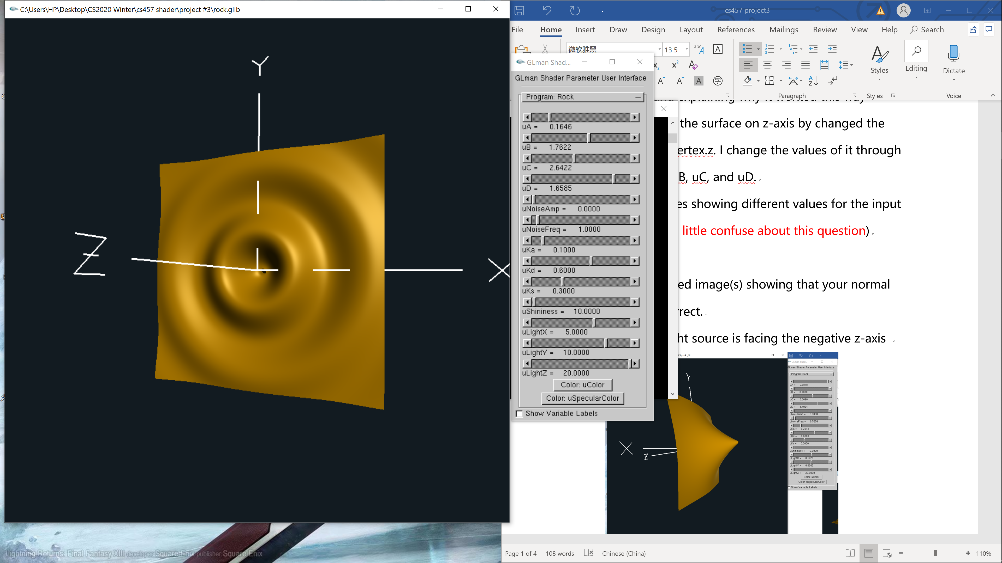

uNoiseAmp: change the noise Ampulitude

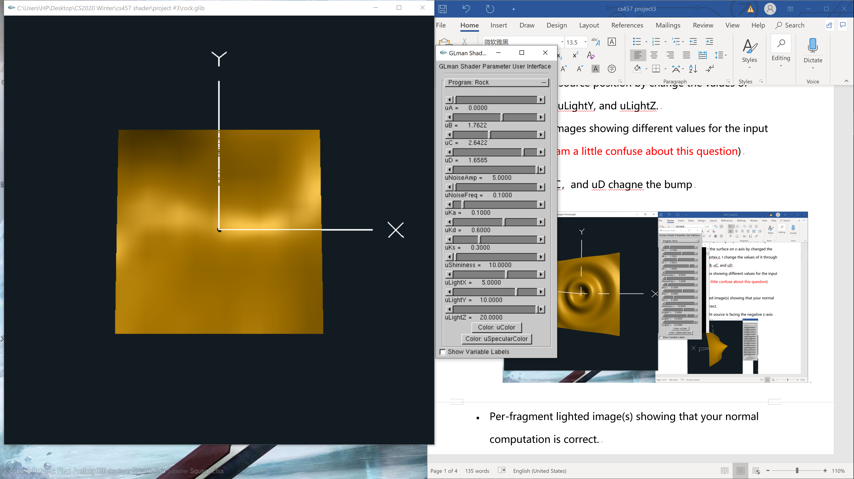

uNoiseFreq： change the Noise Frequency

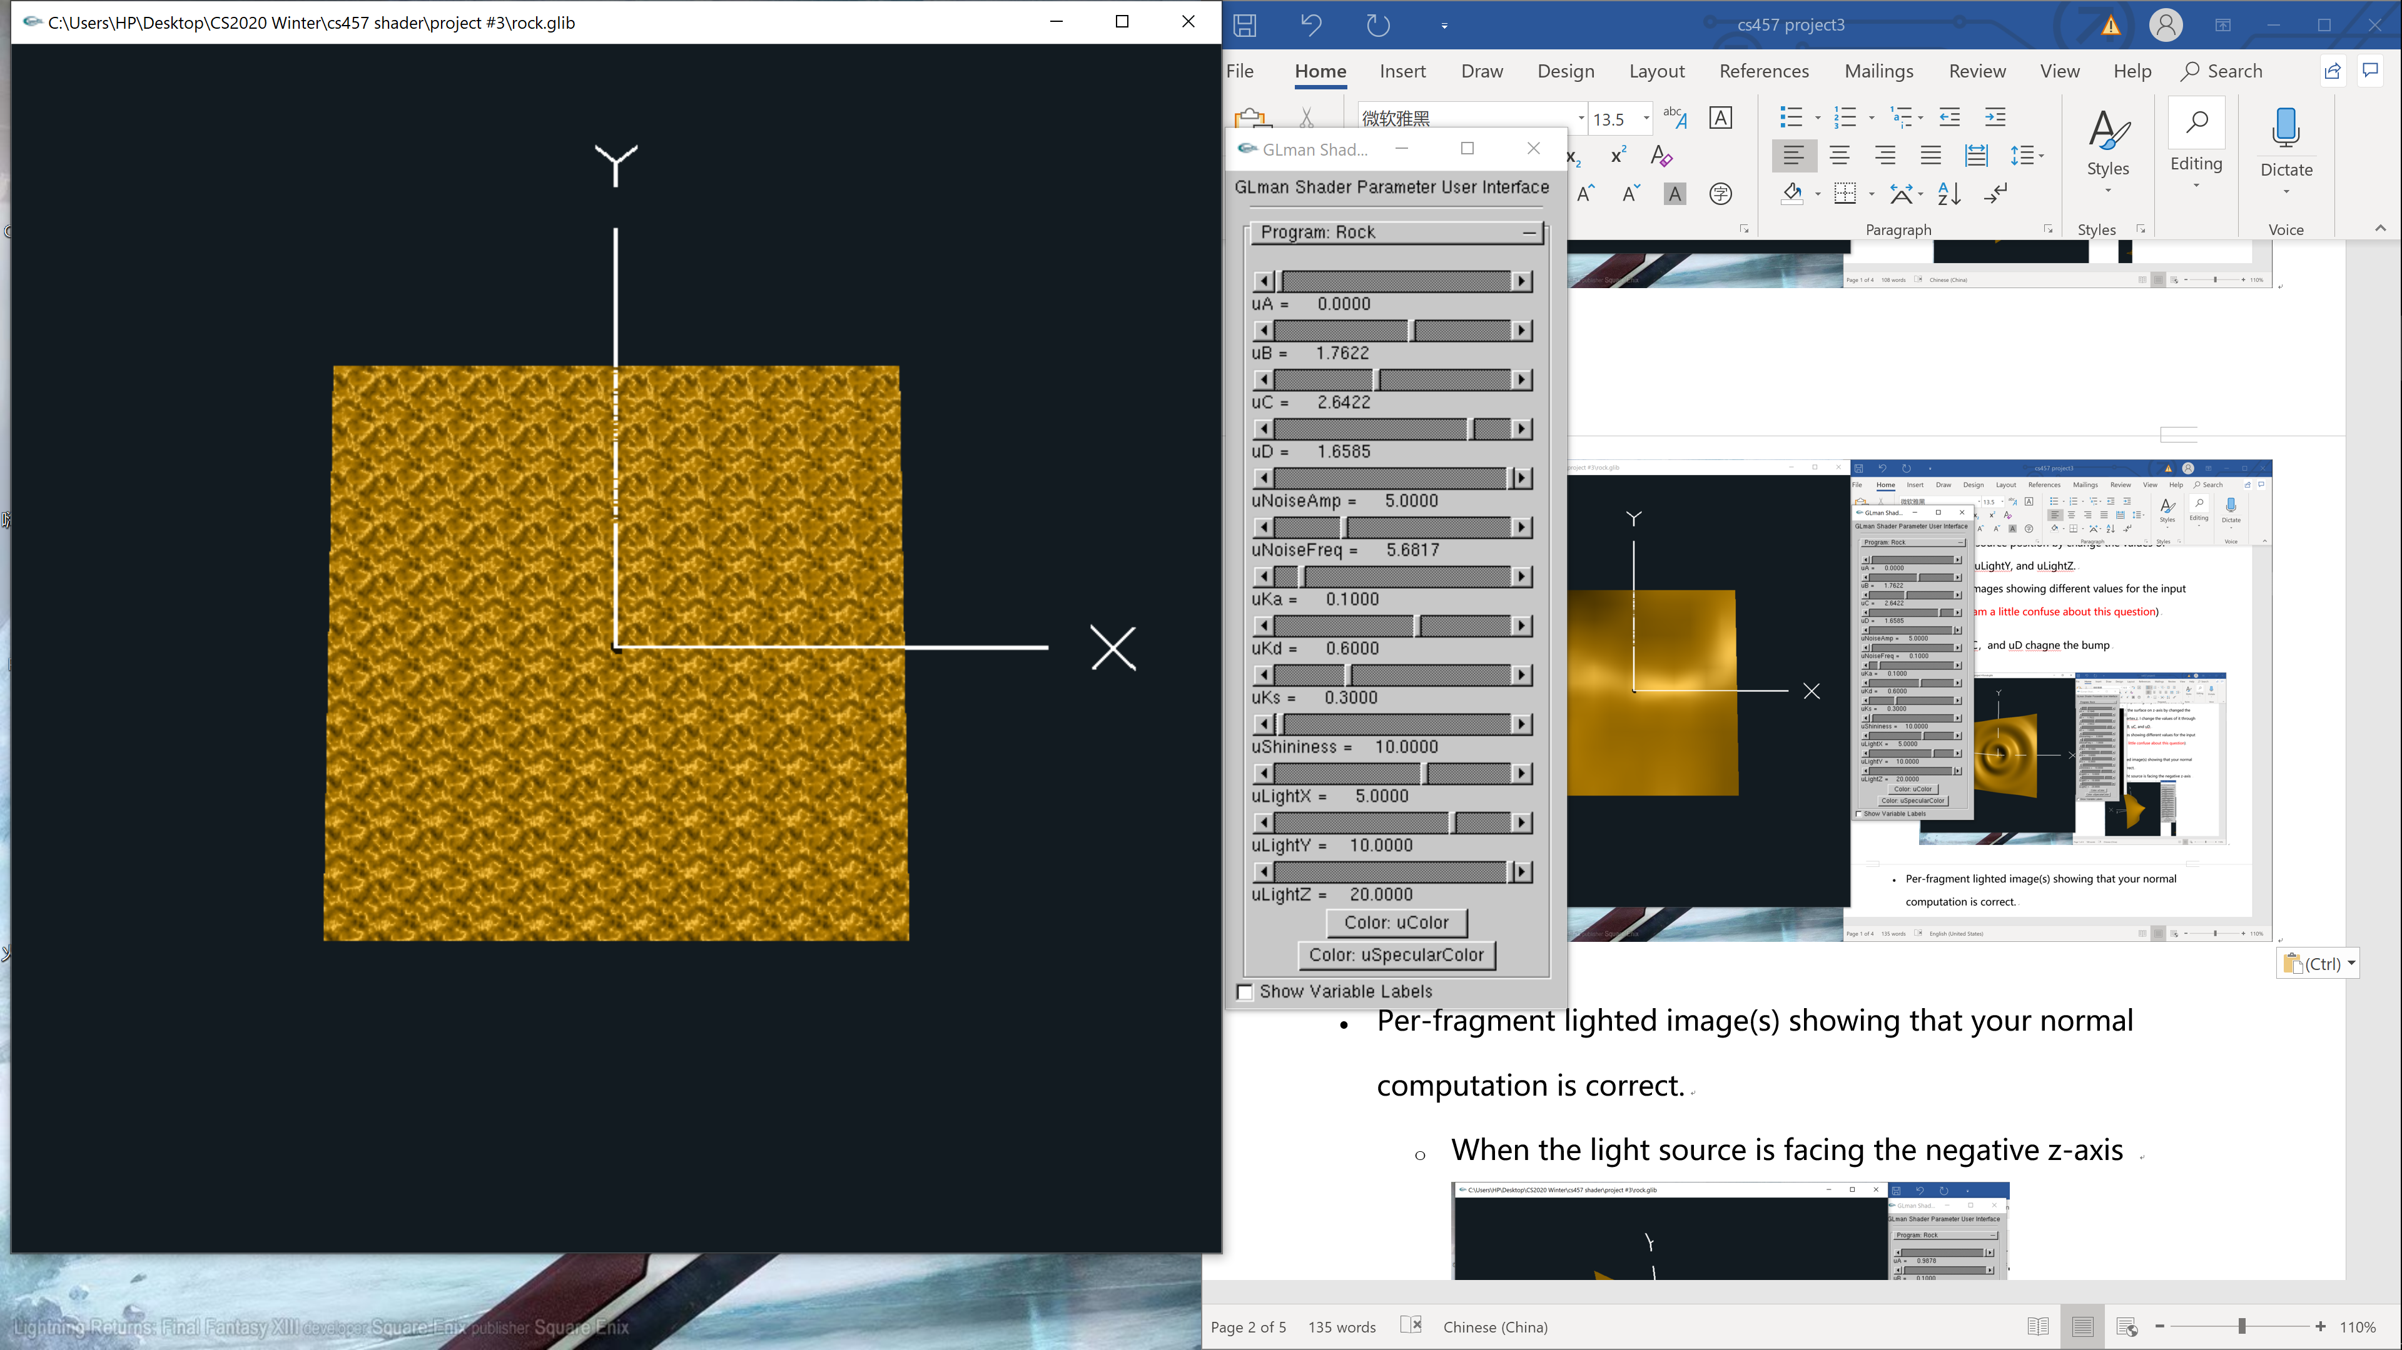

* Per-fragment lighted image(s) showing that your normal computation is correct.
  + When the light source is facing the negative z-axis
  + 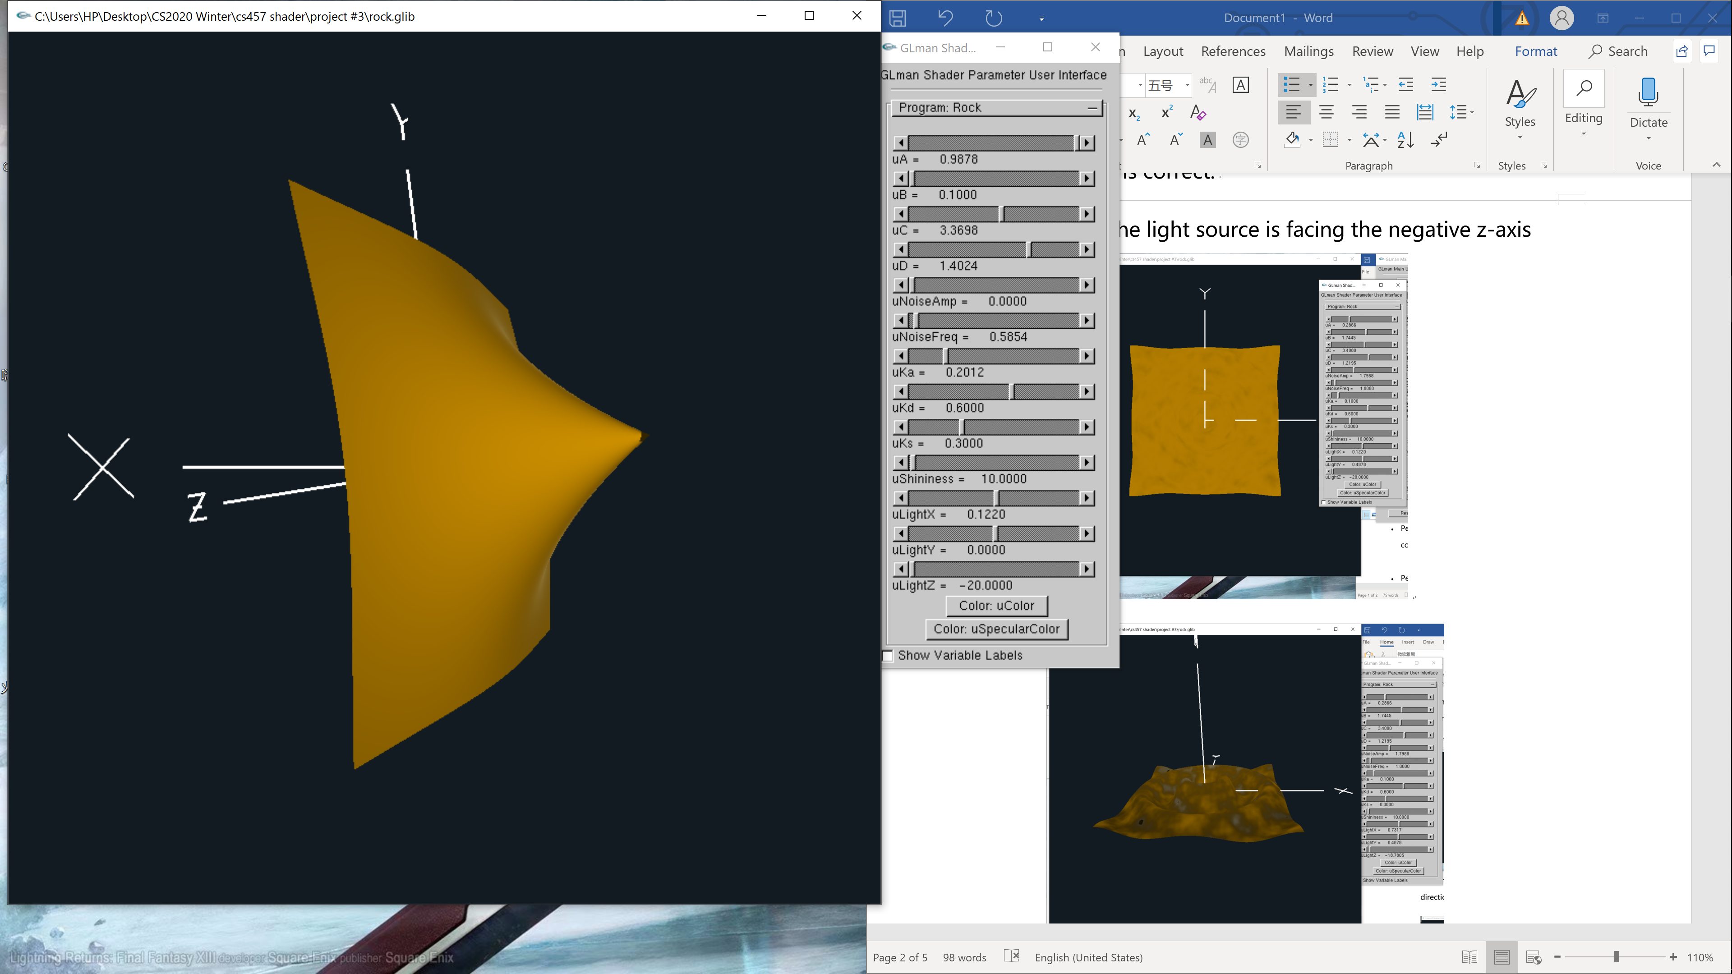

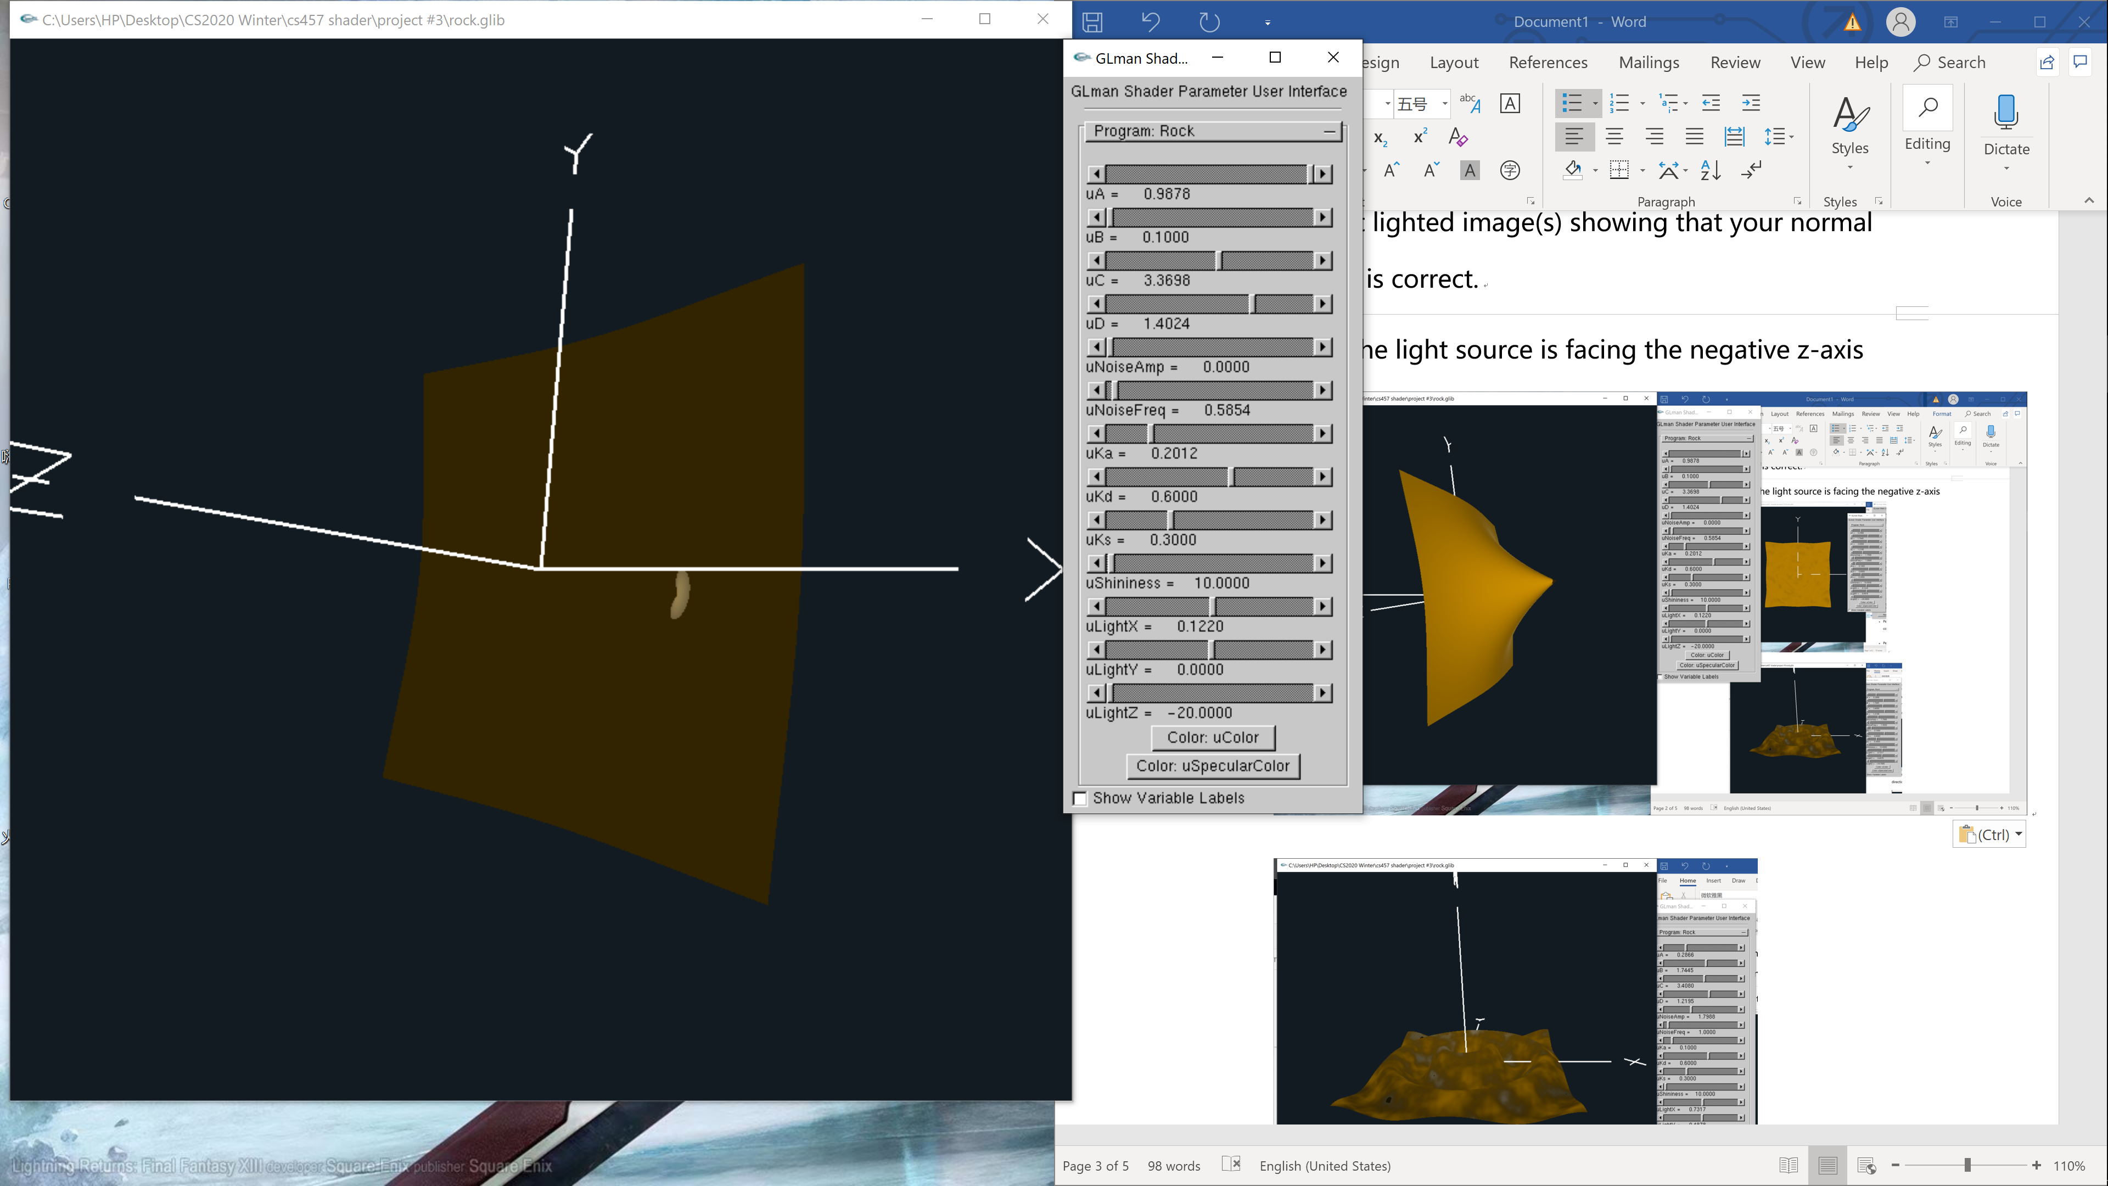

* + When the light source is facing the positive x-axis direction

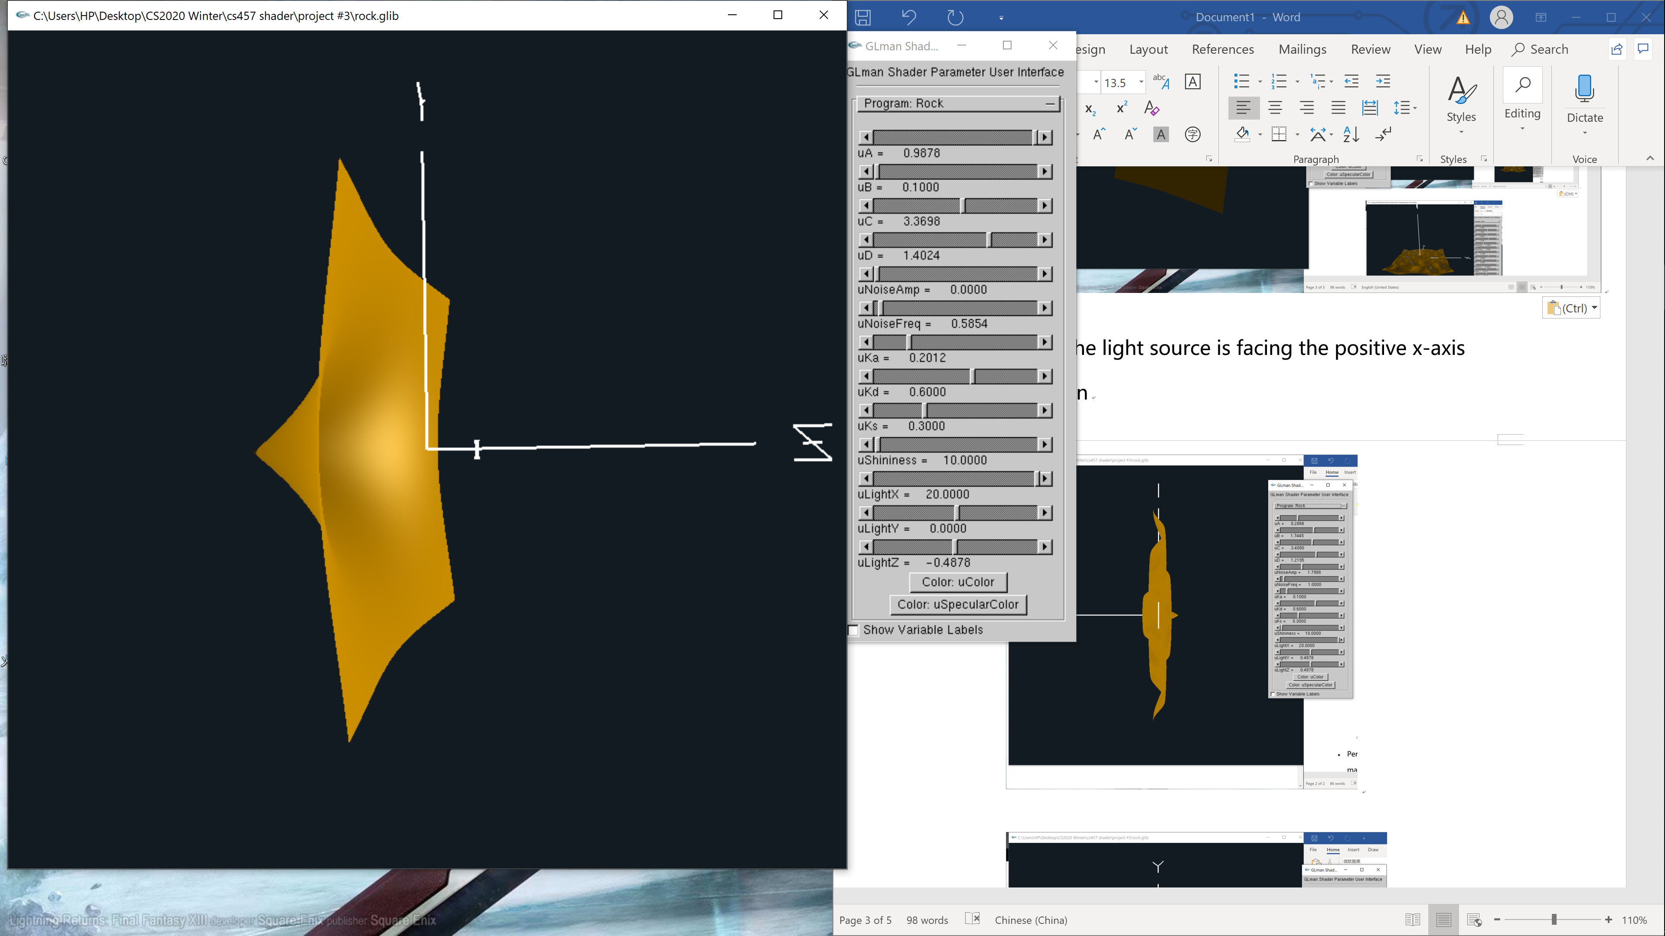

* + 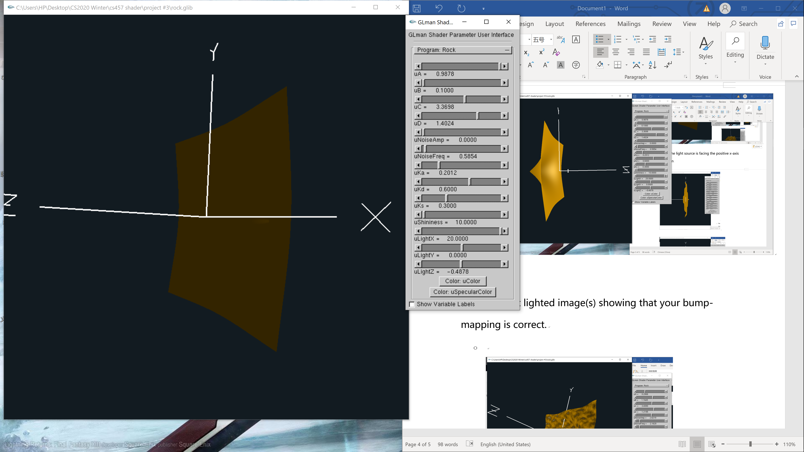
* Per-fragment lighted image(s) showing that your bump-mapping is correct.
  + 
   